ORDER FORM - please email this form together with your deposit slip to:
info@reboundsa.co.za

DESCRIPTION |  | Unit price | Quantity | Total
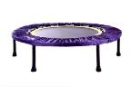
REBOUNDER (Two-fold: they fold in half) with book and DVD
 | HEALTHBOUNCEPRO (Recommended user weight from 25kg to max 120kg)  Includes FREE: Digital DVD 1&2 Compilation and The Miracle Exercise | R2600
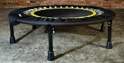 | MAXPRO-HD160 (Locally developed and produced, recommended user weight from 25kg to max 160kg) Includes FREE: Digital video and ebook content | R4500
OPTIONAL ACCESSORIES
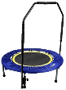  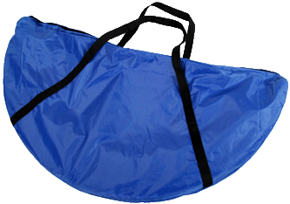 | Canvas Carry Bag | R150
 | Support bars Removable, adjustable support bars. Recommended for people with compromised balance, recovering from injury and illness and the frail. | R450
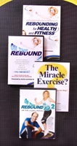
BOOK & DVD’S
 | Rebounding for Health and Fitness BOOK 160 page soft cover book by Keith and Justine McFarlane | R150
 | On the Rebound Compilation - DVD 1 and DVD2 2 x 40 min sessions  Physical DVD | R120
 | “The Miracle Exercise?” DVD 3 information, instruction, Mind Power and quick 2 – 5 min sessions. Running time 60 minutes Physical DVD | R120
 | Essential Health Protocols  An End to All Disease  The Eightfold Pathway  The Little Big Book of Health | R60  R60  R180  R90
SPARE PARTS
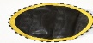 | Replacement Mats (please mark whether 36 spring unit or 32 spring unit) | R350
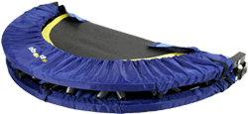 | Replacement Skirts | R350
 | Mat Springs R25 each (R125 for 6 springs) | R25
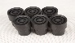 | Rubber leg shoes/ Leg Springs R25 each | R25

DELIVERY OPTIONS Note: for multiple rebound orders, please call or email for a quote - Exclude this section if you are collecting from ReboundSA in JHB (NB: Price per rebounder)
1. Small parcel | Support Bars, Carry Bags, Mats, Skirts, Books & DVD’s | R100
2. JHB Courier | 24 hours (weekdays) Door-to-door courier delivery in the JHB area | R110
PTA Courier | 1 – 2 working days for door-to-door courier delivery to Midrand, PTA East and West & up to Roslyn & Zambezi drive. | R110
Gauteng Surrounding | 2 – 3 working days door-to-door courier delivery Gauteng Surrounding areas | R215
3. Cape Courier | 3 – 4 working days door-to-door courier delivery to W/Cape | R215
PE/East London | 3 – 4 working days door-to-door courier delivery to these Major cities | R215
4. KZN Courier | 2 – 3 working days door-to-door courier delivery to KZN | R215
5. Bloemfontein/  Nelspruit | 2 – 3 working days door-to-door courier delivery to these Major cities | R215
6. Outlying/Farm | Courier to small towns outlying areas and farms – please call for a quote

Total for Rebounder and/or books, DVD’s and Delivery |  | R
NAME | DATE | ReboundSA  STD Bank  Branch: The Glen  Branch Code: 006005  Ac. 041 146 867
DELIVERY ADDRESS If applicable, include any special delivery instructions.

Post Code
Tel Email

(Landline and Cell if possible)

